Verilog Final Exam for CSE 458

1. Write Verilog code and testbench for the following circuit.

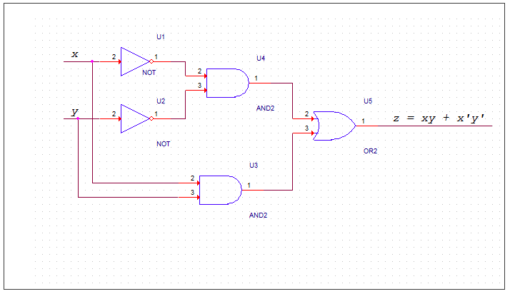

1. Write Verilog code and testbench for the following 4:1 MUX.

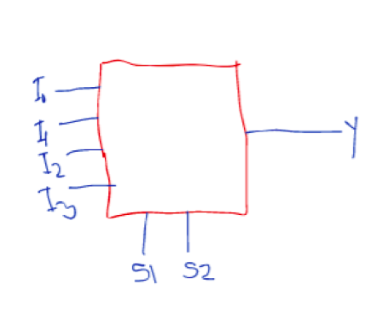

Instructions:

* Write your code in a word file.
* Write code along with comments so that I understand what you are doing

Follow this patter

|  |  |
| --- | --- |
| Code | Comment |
| Module Comparator | //This creates a module |

* Test all possible cases in your testbench.

DON’T COPY & PASTE FROM YOUR FRIENDS.